REACT JS

1. React Ecosystem Overview
React is a UI library (not a full framework) that helps you build interactive, component-based interfaces. Key parts of the ecosystem:
- Core React: Components, state, props, hooks.
- React DOM: Renders React to the web (for mobile, you’d use React Native).
- Tools: Create React App (CRA), Vite, Next.js (for SSR).
- State Management: Context API, Redux, Zustand (for global state like user auth).
- Routing: React Router (for navigation between pages/screens).

2. JSX: JavaScript + XML
JSX lets you write HTML-like syntax in JavaScript.

Key Points:
- Not HTML: JSX is syntactic sugar for React.createElement().
- Embed Expressions: Use { } to inject dynamic values.
- Must Return One Root Element: Use fragments (<> </>) for multiple elements.

Example: Rentify Property Card
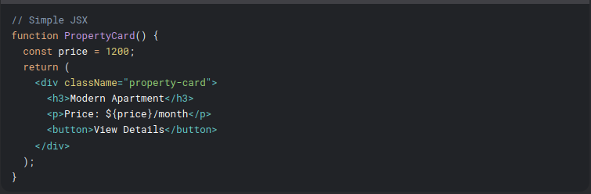
⚠️ Pitfalls:
- Class vs ClassName: JSX uses className, not class.
- Inline Styles: Use objects (style={{ color: 'red' }}).

3. Components: Building Blocks of React

A. Function Components (Modern, Preferred)
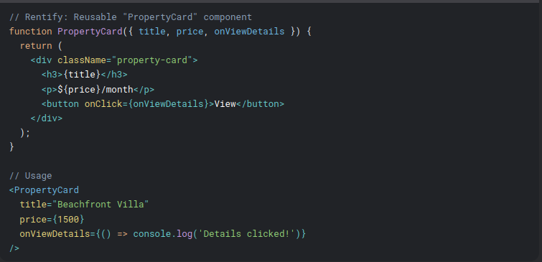

B. Class Components (Legacy, Rarely Used Now)
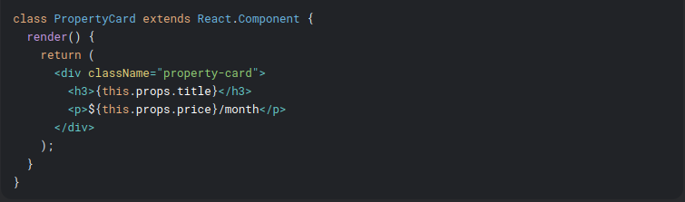
📌 Best Practices:
- Use function components + hooks (99% of modern React).
- Name components in PascalCase (e.g., PropertyCard).
- Keep components small and reusable (e.g., separate PropertyCard and PropertyList).

4. Props: Passing Data to Components
Props (short for "properties") are how components communicate.

Key Rules:
- Read-Only: Components should never modify their props.
- Type Checking: Use PropTypes or TypeScript for safety.

Example: Rentify Property List

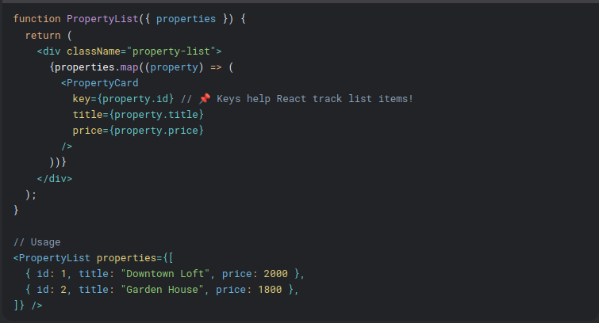
⚠️ Edge Cases:
- Missing Props: Use default values
  - (PropertyCard.defaultProps = { price: 0 }).
- Performance: Avoid passing inline functions
  - (onClick={() => ...}) in lists (use useCallback later).

Understanding State in React

What is State?
State is dynamic data that changes over time (e.g., user input, API responses). Unlike props, state is internal to a component.

A. useState (Function Components)
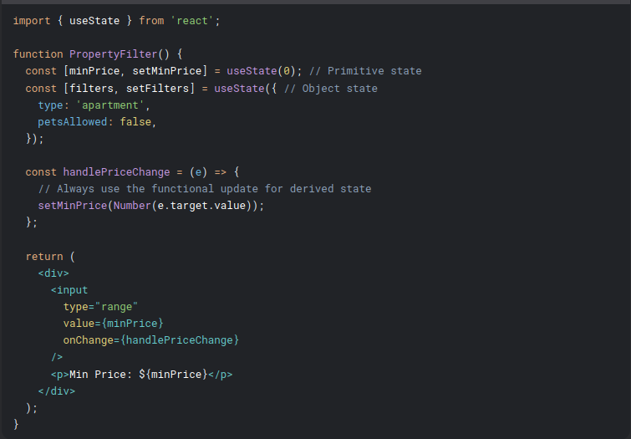
📌 Key Points:
- Use descriptive state names (e.g., minPrice vs price).
- For objects/arrays, always spread previous state to avoid partial updates:
setFilters(prev => ({ ...prev, petsAllowed: !prev.petsAllowed }));
⚠️ Pitfalls:
- Stale State: If the new state depends on the old, use the functional form (setMinPrice(prev => prev + 10)).
- Immutability: Never mutate state directly
(filters.petsAllowed = true → BAD!).

B. this.state (Class Components - Legacy)
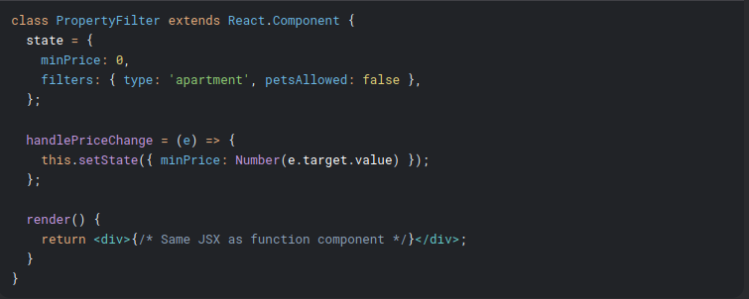
🔄 When to Use Class Components?:
- Rarely! Only if maintaining legacy code or using ErrorBoundaries (componentDidCatch).

2. Component Lifecycle

A. useEffect (Function Components)
Replaces lifecycle methods (componentDidMount, componentDidUpdate, componentWillUnmount).

Basic Usage (Fetching Properties for Rentify)
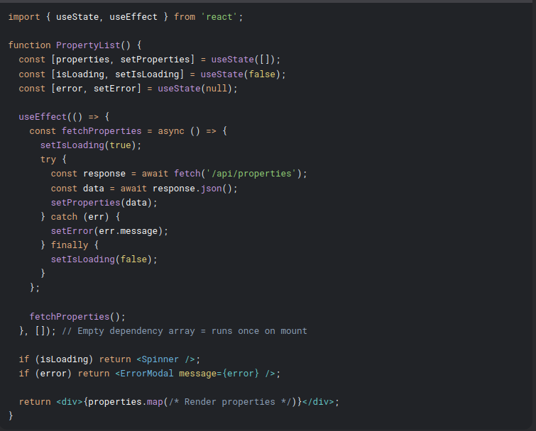
📌 Dependency Array Rules:
- []: Runs once (mount).
- [minPrice]: Runs when minPrice changes.
- No array: Runs on every render (dangerous!).
⚠️ Common Mistakes:
- Missing Dependencies: If you use a state/prop inside useEffect, add it to dependencies.
- Cleanup Neglect: Cancel API requests or subscriptions to prevent memory leaks:
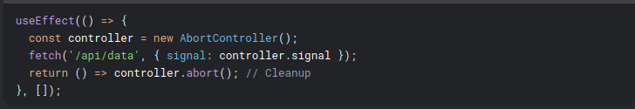

B. Class Lifecycle Methods (Comparison)
Function Component | Class Component | Use Case
useEffect(() => {}, []) | componentDidMount | Fetch data on initial render.
useEffect(() => {}) | componentDidUpdate | Run logic on prop/state changes.
useEffect(() => () => {}) | componentWillUnmount | Cleanup (e.g., event listeners).

3. Advanced State Management

A. useReducer (Complex State Logic)
Ideal for state with multiple sub-values (e.g., filters in Rentify):

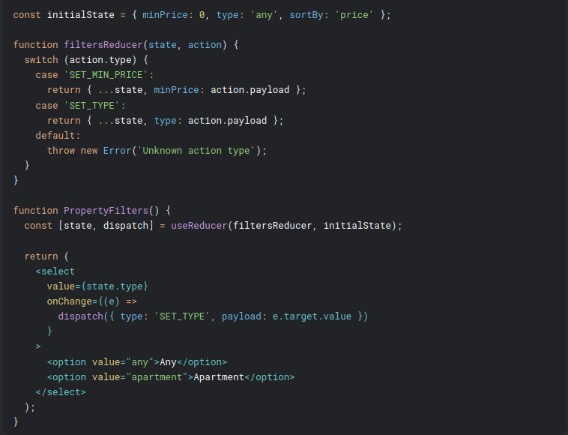
📌 When to Use:
- State has complex update logic.
- Multiple state values change together (e.g., form validation).

B. State Lifting (Shared State Between Components)
For Rentify, if PropertyList and PropertyFilter need to share state:
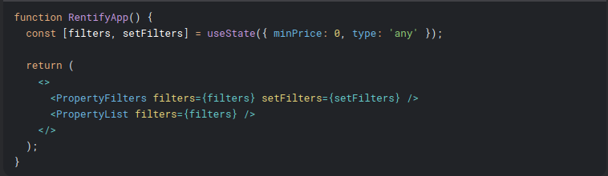
🧠 Best Practice:
- Lift state to the lowest common parent.
- Avoid prop drilling with Context (covered later).

4. Real-World Rentify Example

Production-Ready Property Search
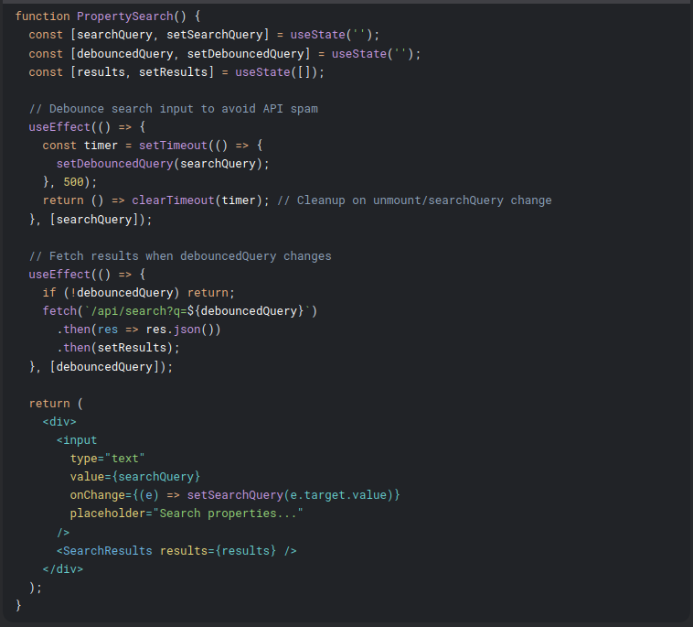
🚀 Key Optimizations:
- Debouncing: Prevents API calls on every keystroke.
- Cleanup: Avoids race conditions with clearTimeout.

Edge Cases & Pitfalls
- Stale Closures:
  - In useEffect, if you use a state variable without adding it to dependencies, it becomes stale.
  - Fix: Use the dependency array correctly or useRef for mutable values.
- Infinite Loops:
  - Updating state inside useEffect without proper dependencies triggers re-renders.
  - Example:
jsx
- useEffect(() => {
setCount(count + 1); // 🔴 Infinite loop if `count` is a dependency
}, [count]);
- Memory Leaks:
- Forgetting to cancel API requests on unmount can cause errors like:
"Can't perform state update on an unmounted component."
- Always use cleanup functions.

Handling Forms and Events in React (Beginner to Advanced)
Forms are critical for Rentify (user logins, property listings, filters). We'll cover everything from basic form handling to advanced patterns like dynamic fields, validation, and form libraries.

1. Basic Form Handling

Controlled Components (Recommended)
Form inputs are tied to React state.
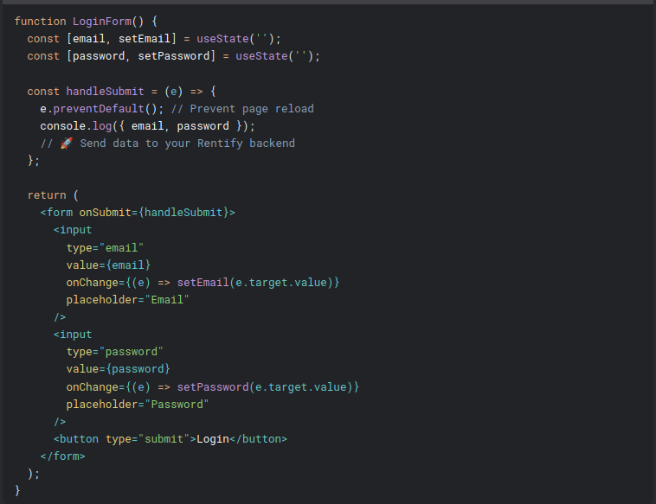
📌 Key Points:
- e.preventDefault(): Stops the default form submission behavior.
- Controlled Inputs: Bind value to state and update via onChange.
- <button type="submit">: Triggers the form’s onSubmit.
⚠️ Pitfalls:
- Stale State: If state updates are asynchronous (e.g., API calls), use a ref or await the state update.
- Performance: Avoid inline arrow functions in onChange for large forms (use useCallback later).

2. Handling Multiple Inputs

Dynamic State Management
Instead of individual state variables, use a single object for form state.
jsx
function PropertyForm() {
const [formData, setFormData] = useState({
title: '',
price: '',
bedrooms: 1,
petsAllowed: false,
});

const handleChange = (e) => {
const { name, value, type, checked } = e.target;
setFormData(prev => ({
...prev,
[name]: type === 'checkbox' ? checked : value,
}));
};

return (
<form>
<input
name="title"
value={formData.title}
onChange={handleChange}
placeholder="Property Title"
/>
<input
name="price"
type="number"
value={formData.price}
onChange={handleChange}
placeholder="Price"
/>
<input
name="petsAllowed"
type="checkbox"
checked={formData.petsAllowed}
onChange={handleChange}
/>
<label>Pets Allowed</label>
</form>
);
}
📌 Best Practices:
- Use name attributes matching state keys.
- Handle checkboxes/radios differently (checked vs value).

3. Form Validation

Basic Validation (Inline)
jsx
function SignupForm() {
const [formData, setFormData] = useState({ email: '', password: '' });
const [errors, setErrors] = useState({});

const validate = () => {
const newErrors = {};
if (!formData.email) newErrors.email = 'Email is required';
if (formData.password.length < 6) newErrors.password = 'Password too short';
setErrors(newErrors);
return Object.keys(newErrors).length === 0;
};

const handleSubmit = (e) => {
e.preventDefault();
if (validate()) {
console.log('Form is valid!');
}
};

return (
<form onSubmit={handleSubmit}>
<input
name="email"
value={formData.email}
onChange={handleChange}
/>
{errors.email && <span className="error">{errors.email}</span>}
<input
name="password"
type="password"
value={formData.password}
onChange={handleChange}
/>
{errors.password && <span className="error">{errors.password}</span>}
<button type="submit">Sign Up</button>
</form>
);
}

Advanced Validation (Schema-Based)
Use libraries like Yup or Zod for complex validation:
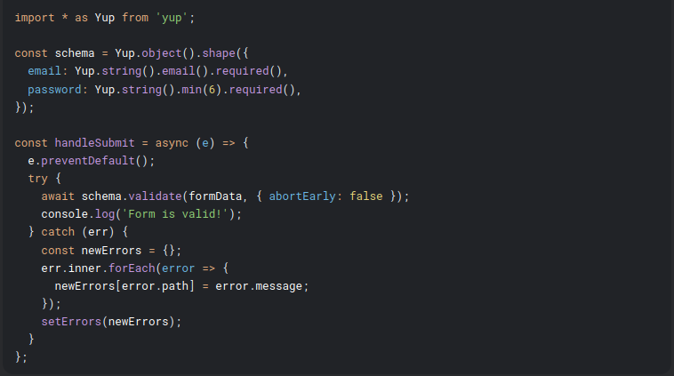
📌 When to Use:
- Simple forms: Inline validation.
- Complex forms: Yup/Zod for reusable rules.

4. Dynamic Fields (Adding/Removing)
For Rentify’s property features (e.g., amenities):
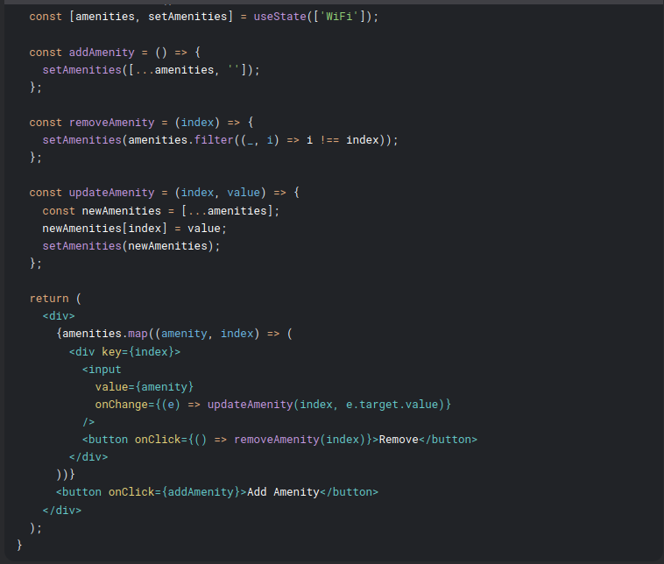
⚠️ Edge Cases:
- Key Prop: Always use a unique key (e.g., index is okay if the list is stable).
- Performance: For large lists, use React.memo or virtualization.

5. Production-Ready Form Handling

Using Form Libraries (React Hook Form)
For Rentify, consider React Hook Form for performance and scalability:
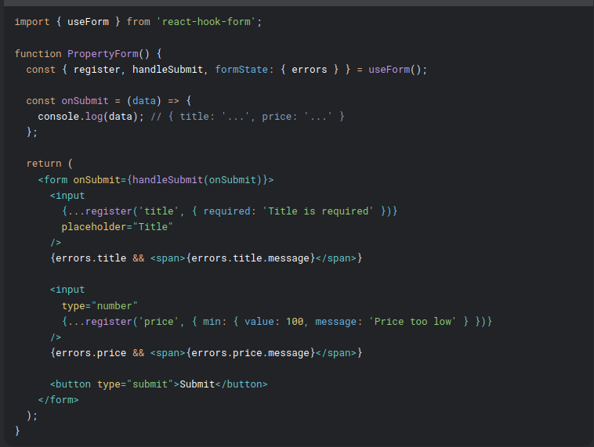
🚀 Why React Hook Form?
- Optimized re-renders (no unnecessary updates).
- Built-in validation (with Yup/Zod support).
- Smaller bundle size than Formik.

6. Handling File Uploads (Rentify Property Images)
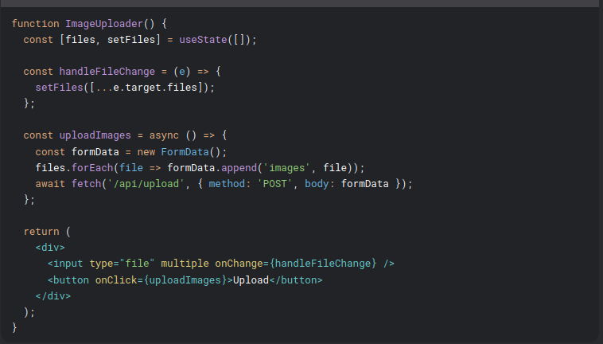
📌 Key Notes:
- Use FormData for file uploads.
- Backend must handle multipart/form-data.

Advanced React: Conditional Rendering, Lists, and Keys
(Applied to Rentify – Property Rental App)
We'll cover conditional rendering patterns, dynamic lists optimization, and key management with real-world Rentify examples.

1. Conditional Rendering in React

A. Basic Conditional Rendering

If-Else (Simple Conditions)
jsx
function PropertyCard({ property }) {
if (!property) return null; // Early return (guard clause)

return (
<div className="card">
<h3>{property.title}</h3>
{property.isFeatured && <Badge text="Featured" />} // Logical AND
</div>
);
}
📌 Key Points:
- Early returns simplify nested conditions.
- && operator: Renders if condition is truthy.

Ternary Operator (Inline Conditions)
jsx
function Pricing({ price }) {
return (
<div>
{price > 1000 ? (
<PremiumTag />
) : (
<AffordableTag />
)}
</div>
);
}
⚠️ Pitfall: Avoid complex ternaries (use functions/components instead).

B. Advanced Patterns

1. Switch-Case (Multiple Conditions)
jsx
function PropertyStatus({ status }) {
switch (status) {
case 'sold':
return <SoldBadge />;
case 'rented':
return <RentedBadge />;
default:
return <AvailableBadge />;
}
}

2. Enums (Scalable Conditions)
jsx
const STATUS_COMPONENTS = {
sold: SoldBadge,
rented: RentedBadge,
available: AvailableBadge,
};

function PropertyStatus({ status }) {
const StatusComponent = STATUS_COMPONENTS[status] || AvailableBadge;
return <StatusComponent />;
}
🚀 Best Practice: Use enums for >3 conditions (better maintainability).

2. Rendering Lists in React

A. Basic List Rendering
jsx
function PropertyList({ properties }) {
return (
<div>
{properties.map((property) => (
<PropertyCard key={property.id} property={property} />
))}
</div>
);
}
📌 Key Rules:
- Always use key: Helps React identify changes (use unique IDs, not indexes).
- Avoid inline arrow functions in map: Causes unnecessary re-renders.
⚠️ Pitfall: Using index as key:
jsx
// 🚨 Avoid this (causes bugs with reordering/filtering)
{properties.map((property, index) => (
<PropertyCard key={index} property={property} />
))}

B. Advanced List Patterns

1. Virtualized Lists (Performance)
For Rentify’s large property listings:
jsx
import { FixedSizeList as List } from 'react-window';

const VirtualizedList = ({ properties }) => (
<List
height={600}
itemCount={properties.length}
itemSize={150}
width="100%"
>
{({ index, style }) => (
<div style={style}>
<PropertyCard property={properties[index]} />
</div>
)}
</List>
);
📌 When to Use:
- Lists with 100+ items.
- Complex items (e.g., property cards with images).

2. Pagination (API Integration)
jsx
function PropertyGallery() {
const [page, setPage] = useState(1);
const [properties, setProperties] = useState([]);

useEffect(() => {
fetch(`/api/properties?page=${page}`)
.then(res => res.json())
.then(setProperties);
}, [page]);

return (
<div>
<PropertyList properties={properties} />
<button onClick={() => setPage(p => p - 1)}>Previous</button>
<button onClick={() => setPage(p => p + 1)}>Next</button>
</div>
);
}
🧠 Optimization:
- Cache results with SWR/React Query.
- Implement infinite scroll for mobile UX.

3. Handling Empty/Fallback States
jsx
function PropertyList({ properties, isLoading, error }) {
if (error) return <ErrorScreen />;
if (isLoading) return <Spinner />;
if (!properties.length) return <EmptyList />; // Rentify: "No properties found"

return (
<div>
{properties.map((property) => (
<PropertyCard key={property.id} property={property} />
))}
</div>
);
}
📌 Best Practices:
- Always handle loading, error, and empty states.
- Use skeleton loaders for smoother transitions.

4. Key Management Deep Dive

Why Keys Matter
Keys help React:
- Track element identity during re-renders.
- Reorder/filter lists efficiently.

Choosing Keys
Good Keys | Bad Keys
Unique IDs (property.id) | Array indexes (index)
Composite keys (${id}-${type}) | Random values (Math.random())

Fixing Key Issues in Rentify
jsx
// 🚨 Problem: Duplicate keys in nested lists
{properties.map(property => (
<div key={property.id}>
{property.amenities.map((amenity, index) => (
<span key={index}>{amenity}</span> // 🚫 Index is unstable!
))}
</div>
))}

// ✅ Solution: Unique composite keys
{property.amenities.map(amenity => (
<span key={`${property.id}-${amenity}`}>{amenity}</span>
))}

5. Real-World Rentify Example

Dynamic Filters + Conditional List
jsx
function PropertySearch() {
const [searchTerm, setSearchTerm] = useState('');
const [properties, setProperties] = useState([]);
const [isPremiumUser, setIsPremiumUser] = useState(false);

const filteredProperties = properties.filter(property => {
const matchesSearch = property.title.includes(searchTerm);
const matchesTier = isPremiumUser || !property.isPremium;
return matchesSearch && matchesTier;
});

return (
<div>
<input
value={searchTerm}
onChange={(e) => setSearchTerm(e.target.value)}
placeholder="Search properties..."
/>
<label>
<input
type="checkbox"
checked={isPremiumUser}
onChange={() => setIsPremiumUser(!isPremiumUser)}
/>
Show Premium Listings
</label>
{filteredProperties.length > 0 ? (
<VirtualizedList properties={filteredProperties} />
) : (
<EmptyList />
)}
</div>
);
}
🚀 Optimizations:
- Memoize filtered lists with useMemo:
jsx
- const filteredProperties = useMemo(() => (
properties.filter(/* logic */)
), [properties, searchTerm, isPremiumUser]);
- Debounce search input to avoid excessive filtering.

